FACILITATOR NOTES
FACILITATOR NOTES
Designing and delivering great remote lessons
Use these notes alongside your presentation to brief staff on how to deliver remote lessons.

Overview
This staff briefing is designed to:
- Equip staff to adapt their classroom practice to deliver good remote teaching, in line with the latest expectations
- Reassure staff that this is possible, without too much departure from what they’re well-practised in doing and without adding significantly to workload
The briefing is suitable for all teaching staff.
Time to deliver: 60 minutes (plus time for questions, if you take those at the end)

You will need:
- The PowerPoint presentation and handout that accompany these notes (see our article)
- A copy of these facilitator notes
- A lesson plan from each of the participant groups (see the section below for details)
How to prepare
In advance of the briefing, go through the PowerPoint and facilitator notes and add/adapt/delete information wherever text is highlighted yellow.
Where you need to add/adapt information about your school’s plans, the slides include prompts as to what you might want to cover.
- Slide 3 – add information about the technology and resources your school is using for remote teaching
- Slides 14 to 17 – you may wish to change the examples of essential ingredients of great classroom teaching and how to transfer them to remote teaching, depending on your school’s priorities and approach to remote learning. On slide 14 there’s also a bullet point to adapt depending on whether you’re a primary or secondary school
- Slide 18 – our expert suggested www.canva.com for designing mobile-friendly resources, so you may wish to look at this in advance. We’ve also suggested that staff could check whether pupils can access remote learning via a games console, so you may wish to check whether this is possible with any online learning platform you may be using
- Slide 19 – (see the note just below this bullet list)
- Slide 21 – adapt the pupil collaboration strategies according to the online learning platform/tools your school is using
- Slide 24 (optional slide) – if you adapted slide 15 and didn’t include classroom routines, you could include those tips here, adapting the examples to suit your school
- Slide 25 (optional slide) – our expert suggested 2 apps to use here, www.edpuzzle.com and www.thinglink.com, so you may wish to look at these in advance
- Slide 26 – add examples of the resources your staff have at their disposal, and how any online learning platform/tools your school is using can help staff solve particular problems. You may also wish to note who staff can contact for support with technology
- Slide 28 – add details of who your staff can contact with different issues
- Slide 29 – you may wish to change or add to the key takeaways from the session
- Slide 30 – if you’ve used any additional sources when adapting the briefing, add them here
If you’ll be delivering the briefing remotely, use the tips in our article to help you prepare.
How to organise groups for the activity (slide 19)
In slide 19, participants will break into smaller groups to discuss how to adapt a classroom-based lesson plan into a remote lesson plan.
- Work out the groups in advance – aim for 3 or 4 teachers per group
- For primary schools, group teachers together by year group or phase
- For secondary schools, group teachers by subject
- Ask one person from each group to send you a classroom lesson plan in advance of the session (one they’ve already made – no need to create something new for the session)
- If you’re delivering this briefing remotely, put the lesson plans in a shared folder everyone will be able to access during the session, each one labelled clearly for each group
- If you’re delivering this in person, print enough copies for everyone in each group to have their own copy of the lesson plan they’ll be looking at (so they can maintain social distancing during the discussion)
Symbol key:
- What to cover/tell staff
 Instructions or notes
• Instructions for video


Introduction
15 minutes
Resources required: n/a
1 | 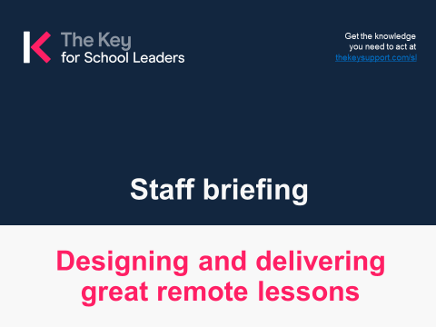 |  |  In advance: wherever text in a slide is highlighted yellow, please add/adapt/delete as necessary   In advance: decide who’ll be in each group for the activities, and ask someone from each group to send you a lesson plan in advance – if delivering this briefing in person, print a copy for each person in their group; if delivering remotely, save them in a shared folder that attendees can access during the briefing   On the day: if you’re delivering the briefing remotely, check your technology is working   Welcome staff to the briefing and:  - Acknowledge their commitment so far to supporting their pupils and school community  - Acknowledge that they may feel anxious or uncertain about delivering remote teaching  - Emphasise that great remote teaching is achievable for all teachers, and the school will support them to do it well
2 | 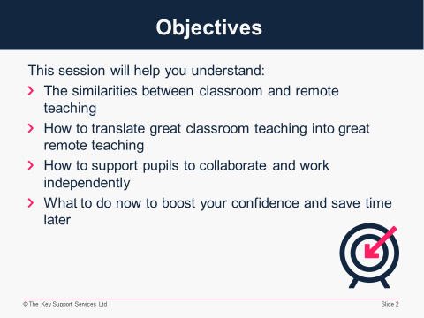 |  |  Share the objectives for this briefing   Reassure staff that remote teaching shares many of the same characteristics of classroom teaching and is simply a different way of delivering what they are already doing well
3 | 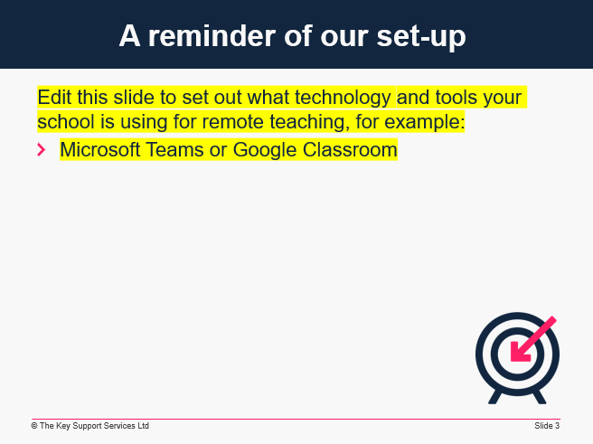 |  | Edit this slide to set out what technology and tools your school is using, for example Google Classroom or Microsoft Teams.  - Briefly remind staff what technology and resources are available to them.
4 | 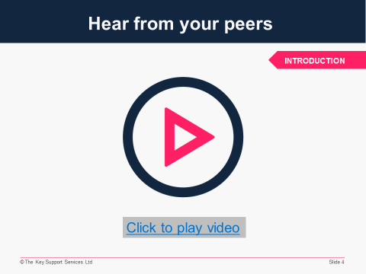 |  | - Tell staff you’re going to hear from a real teacher, including:  - What she was worried about before she started teaching remotely  - How she feels about it now  - A couple of top tips for recording remote learning content  Play the video (2 minutes, 3 seconds).  - Please note: you need to be playing the slide show to be able to click the link on the slide and play the video  - Video source: https://vimeo.com/472287266/0553dcc190
5 | 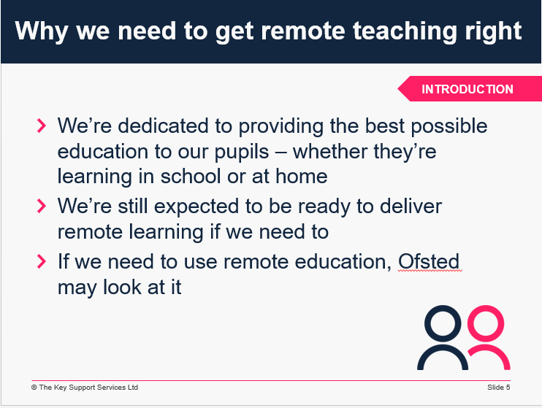 |  | Explain:  Our pupils come first  - First and foremost, we as a school and all of us as individuals care deeply about our pupils  - We want to make sure they progress and achieve well, whether they’re in school or learning at home  - We want to help mitigate the disruption caused by COVID-19 and help our pupils stay engaged with their work and continue to enjoy their learning  We’re still expected to be able to deliver it if we need to  - The government still expects us to maintain our capacity to deliver high-quality remote education across this academic year, including for pupils who are abroad, and facing challenges to return due to COVID-19 travel restrictions, for the period they are abroad  Ofsted might look at it  - If we need to use remote education, inspectors may observe remote teaching and review materials
6 | 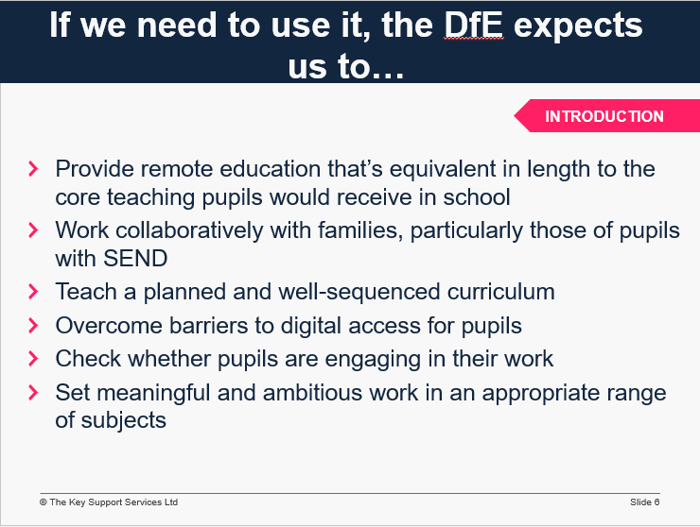 |  | - Explain that the DfE still has expectations for what remote teaching should look like.  - Read out the points below and then reassure staff of the similarities to what makes good classroom teaching.  - Provide remote education that’s equivalent in length to the core teaching pupils would receive in school  - Work collaboratively with families and put in place reasonable adjustments so that pupils with SEND can access it  - Teach a planned and well-sequenced curriculum  - Overcome barriers to digital access for pupils  - Check whether pupils are engaging in their work  - Set meaningful and ambitious work in an appropriate range of subjects
7 | 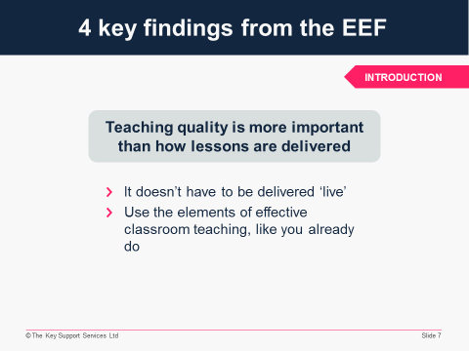 |  | - Explain that during lockdown, the Education Endowment Foundation looked at existing research on remote learning. Over the next few slides, you’re going to look at 4 key findings from their review of the evidence. The first:  Teaching quality is more important than how lessons are delivered  - Pupils can learn through remote teaching as long as the elements of effective teaching are present – for example, clear explanations, scaffolding and feedback  - There was no clear difference between teaching in real time and alternatives. For example, you might explain a new idea live or in a pre-recorded video – what matters most is whether the explanation builds clearly on prior learning or how understanding is subsequently assessed  - In section 1 of this briefing, we’ll see how the ‘essential ingredients’ of your lessons can be transferred to remote teaching
8 | 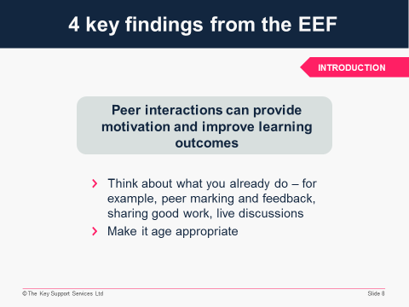 |  | - Tell staff the second key finding from the EEF you’re going to look at is:  Peer interactions can provide motivation and improve learning outcomes  - There are many ways to do this, including peer marking and feedback, sharing models of good work, and opportunities for live discussions of content – many of these will align with what you already do in classroom teaching  - Many of the studies involved older learners, so we need to think carefully about what will work best for different age groups  - We’ll cover how you can build in peer interactions in more detail later on in the briefing
9 | 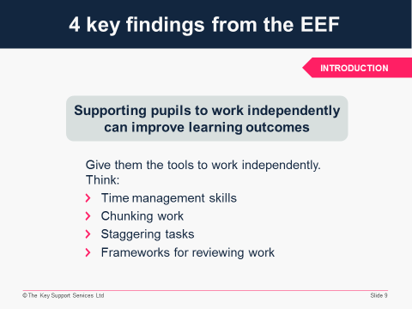 |  | - The third key finding you’re going to look at is:  Supporting pupils to work independently can improve learning outcomes  - Pupils have different levels of support when learning remotely – some may be working completely independently  - To improve learning outcomes, we need to equip pupils with the tools to work independently and stay motivated – this is particularly important for disadvantaged pupils  - We’ll also cover this point in more detail later on, but some tools you can use are:  - Time management skills  - Chunking work and staggering tasks  - Giving pupils frameworks for reviewing their own work (like a checklist or peer reviewing)
10 | 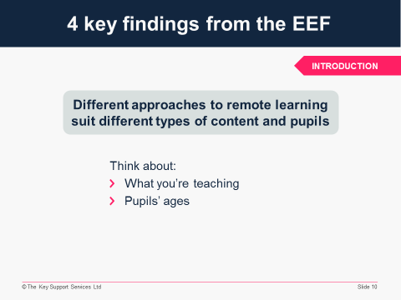 | - The fourth key finding is:  Different approaches to remote learning suit different types of content and pupils  - Approaches to remote learning vary widely – we need to make sure our approaches suit the content being taught and the age of our pupils  - We’ll be looking at different aspects of remote teaching during this briefing   The fifth finding from the EEF’s research – “Ensuring access to technology is key, particularly for disadvantaged pupils” – is mostly beyond the scope of this briefing, but you may wish to mention it as it does link to slide 18 (about mobile-friendly resources).

Section 1: fundamentals of remote teaching
25 minutes

Resources required: A lesson plan for each of the groups you’ve organised for the activity
11 | 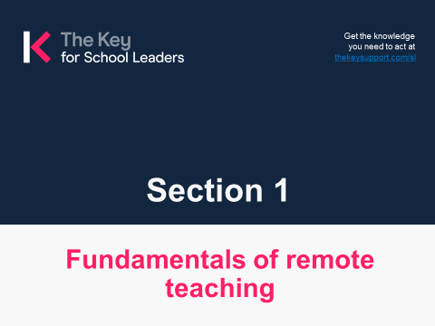
12 | 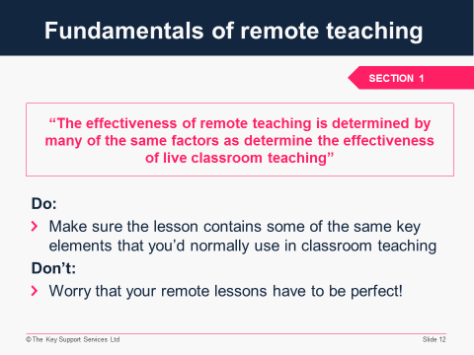 | - Explain:  - This quote, from the DfE’s guidance on remote education good practice, highlights that remote teaching shares many of the key attributes of classroom teaching  - The skills you use every day in the classroom are transferrable to remote delivery  - Your remote lessons don’t need to be perfect –  good teaching is more important than the medium  of delivery, be it in school vs remote, or live vs  pre-recorded  - Think of it like this: it’s the same essential elements  of your classroom practice, just delivered in a  different way
13 | 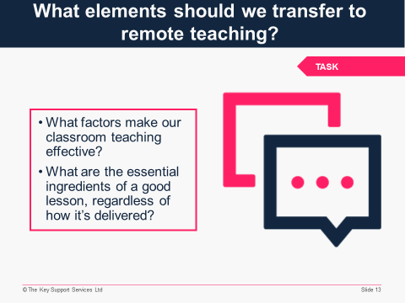 | - Explain to staff that this is a very quick exercise (2-3 mins) to get them thinking about the similarities between their current classroom practice and remote teaching.  In the previous slide, we noted how the effectiveness of remote teaching is determined by many of the same factors as classroom teaching. So:  - What factors make our classroom teaching effective?  - What are the essential ingredients of a good lesson, regardless of how it’s delivered?  Please share your thoughts with the group. There are no right or wrong answers!  Acknowledge the ideas that have been shared and explain that in the next few slides we’ll look at a few ‘essential ingredients’ in a bit more detail and see how these could be replicated in a remote lesson.  - If staff are having difficulty thinking of ‘essential ingredients’ of a classroom lesson, you could use some of the examples from the next few slides to guide their thinking.
14 | 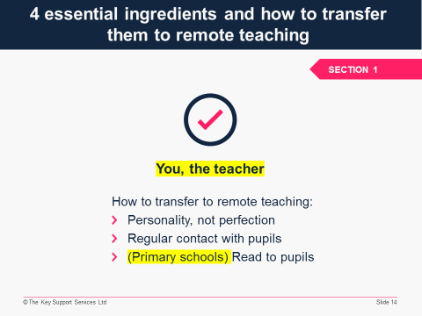 | These 4 suggested essentials and the tips below are designed to get people thinking about how they can translate key elements of classroom practice, but you could adapt or add to this slide according to your school’s own priorities and approach to remote learning.  If you’re in a secondary school, delete the final bullet point on the slide and below. If you’re in a primary school, delete the yellow highlighted ‘(Primary schools)’.   Explain:  We’re now going to look at 4 essential ingredients of lessons that can be transferred to remote lessons. Let’s look at what these are, and different ways we can transfer them to remote teaching. First:  You, the teacher  - When pupils are away from school the most important thread to maintain is relationships  - You are, of course, supporting pupils to make academic progress, but what they’ll really miss are the day-to-day interactions with their teacher and classmates  How you could replicate this remotely:  - When delivering live/pre-recorded lessons, focus less on ‘perfect’ delivery and more on making sure your personality shines through  - Make regular contact with pupils, for example via class check-ins and/or individually via phone or video chat (following our safeguarding guidelines)  - (Primary schools) Regularly read to the pupils (live or pre-recorded)
15 | 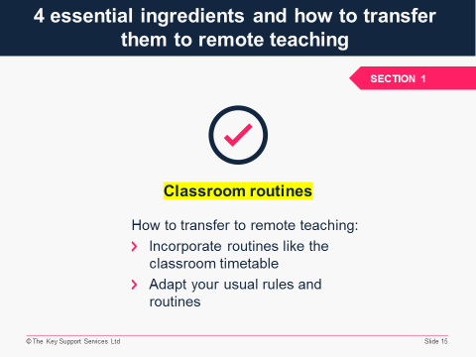 | These 4 suggested essentials and the tips below are designed to get people thinking about how they can translate key elements of classroom practice, but you could adapt or add to this slide according to your school’s own priorities and approach to remote learning.   The next essential ingredient we’re going to look at is:  Classroom routines  It’s really important for pupils to have a sense of normality and familiarity at a time of uncertainty.  How you could replicate this remotely:  - Try to incorporate the routines of your physical classroom – for example, pupils might follow their usual classroom timetable, but remotely  - Try adapting your usual rules and routines – for example, how could children put up their hands remotely? Could pupils peer review work using a shared online document in place of exercise books? Could you use online polls when creating new ideas for lesson starters, to get everyone involved?
16 | 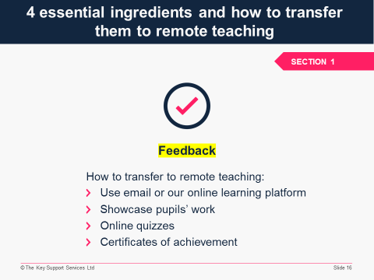 | These 4 suggested essentials and the tips below are designed to get people thinking about how they can translate key elements of classroom practice, but you could adapt or add to this slide according to your school’s own priorities and approach to remote learning.   The third essential ingredient we’re going to look at is:  Feedback from the teacher  It’s vital to give regular, timely feedback to pupils, to keep them motivated and help them understand what they’re doing well and where they can develop.  How you could replicate this remotely:  - Feedback via email/online learning platform  - Showcasing pupils' work in a daily video message  - Low-stakes testing using online quizzes (some platforms/tools enable you to set up auto-feedback to address common misconceptions if a pupil selects an incorrect answer)  - Virtual certificates of achievement for pupils who’ve shown progress each week
17 | 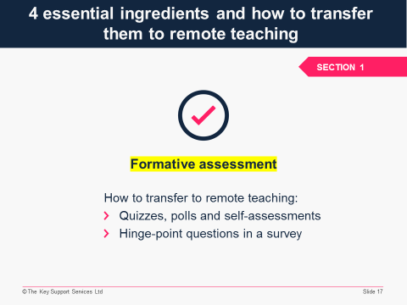 | These 4 suggested essentials and the tips below are designed to get people thinking about how they can translate key elements of classroom practice, but you could adapt or add to this slide according to your school’s own priorities and approach to remote learning.   The fourth and final essential ingredient we’re going to look at is:  Formative assessment  - You need to know what your pupils are learning and how they’re progressing  - In a classroom, you can easily read the room and see who understands and who doesn’t  How you could replicate this remotely:  - Build formative assessment into your lessons through quizzes, polls, self-assessments  - Ask ‘hinge-point’ questions (for example, in the form of an online survey) to check whether the class is ready to move on
18 | 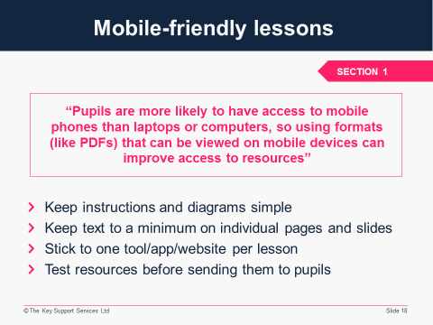 | The expert we worked with suggested www.canva.com as a tool for designing mobile-friendly resources – you may wish to mention it here if you’re happy for your staff to use it.  You could also encourage staff to check whether pupils can access their learning via a games console, which is likely to be linked to a bigger screen like a TV (for example, they may be able to log in to your school website or online learning platform via a browser function on the console).  - Explain:  As we know, and as the DfE acknowledges in this quote, some pupils will be working remotely on their phone.  In addition to thinking about how phone-friendly different file formats are, we need to consider the size of a phone screen when designing lesson resources:  - Keep instructions and diagrams as simple and easy to read as possible  - Keep text to a minimum on each individual page/slide  - Try to avoid pupils having to jump between different tools, apps or websites during a single lesson or learning activity – this is harder to do on a phone than a laptop  Test out resources on your own phone before you send them to pupils – how does the font look? Are images clear? Is the text easy to scan and digest?  Bear in mind that working on a small screen non-stop isn’t comfortable – try to incorporate tasks that pupils can do offline.  Think about how printer-friendly your resources are too. You’ll need to provide printed resources for pupils who don’t have online access at all – making sure your resources work well both on and offline will save you needing to make different versions. Many of these principles for mobile-friendly resources will also apply to printed resources.
19 | 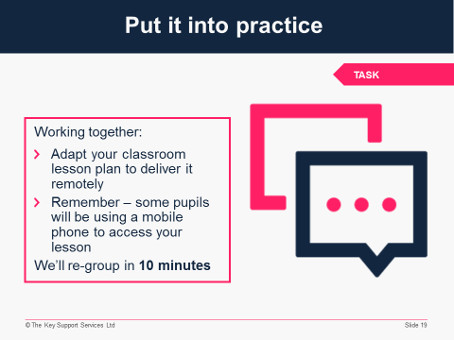 |  Explain:  - You’re going to break into groups to discuss how to adapt a classroom-based lesson plan into a remote lesson plan  - You have 10 minutes  - Working together, decide what the key elements of this lesson are and then:  - What you could replicate when teaching remotely  - What you couldn’t replicate remotely but it doesn’t matter  - What you’d like to replicate remotely but aren’t sure how  When groups return, ask each group (or just a couple, if there are several groups) to share what they’ve discussed.  Summarise the examples shared and discuss possible strategies for any elements staff feel are important to replicate remotely but aren’t sure how.

Section 2: Helping pupils work collaboratively
and independently
6 minutes

Resources required: n/a
20 | 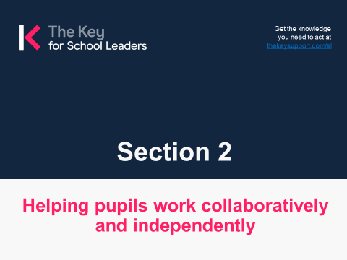
21 | 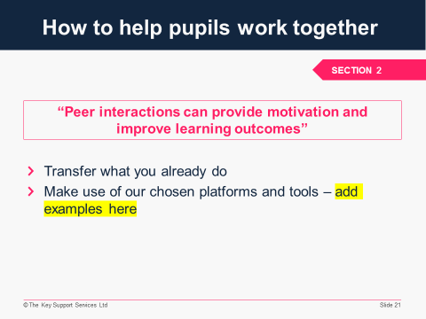 | We’ve included some suggested approaches below, but you’ll need to adapt this slide according to the online learning platform/tools your school is using. If you’re using G Suite for Education or Office 365 Education, here’s a reminder of what it can do and how you might use it: https://schoolleaders.thekeysupport.com/uid/fd07b8a5-42c8-41af-ba18-b9ac0cd97153/  - Explain, and then talk through the bullet points:  As you’ll remember from earlier, this quote is one of the EEF’s findings about remote learning. Let’s think about how we do this in our school.  Transfer what you already do  - Collaboration is a key feature of any good classroom. What good collaboration looks like can vary based on age, stage and subject  - What does good collaboration look like in your classroom? For example, you might use:  - Pair/group work on tasks  - Teacher-led brainstorming  - Discussion groups  - Peer review/marking  - We can replicate many of these elements remotely (though some may need to be more teacher-led than when you’re in the classroom)  Make use of our chosen platforms and tools  - These can help you replicate how pupils work together in the classroom  - Strategies to increase pupil collaboration could include:  - Thoughtful questioning by the teacher and encouraging class participation  - Brainstorming using web-based tools such as Padlet, Jamboard (G Suite) or Whiteboard (Office 365)  - Pupils collaborating on work using Docs  (G Suite) / Class Notebook (Office 365)
22 | 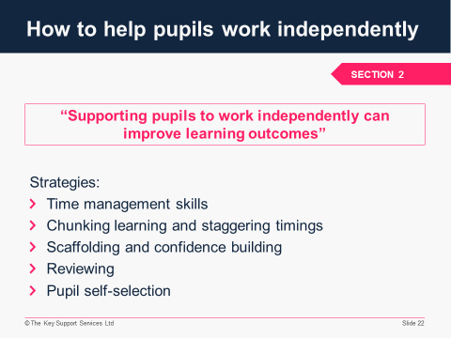 | - Explain:  This quote is another of the EEF findings.  We want our pupils to be able to work independently, but it takes instruction and practice to achieve this. We need to understand the skills that are important and those that we want to develop, and provide scaffolding to help pupils use strategies effectively.  Here are some strategies we can use to help pupils work well independently:  Time management skills:  - Set clear deadlines  - Discuss time estimates with the whole class, so they know roughly how long it should take to complete a piece of work  Chunking learning and staggering timings:  - Chunk learning into manageable tasks that pupils can focus on and complete in a reasonable time – as a guide, expect pupils to concentrate on a task for no longer than their age plus 1 minute  - Stagger the assigning of tasks as well as the timings for submission so pupils don’t feel overloaded  Scaffolding and confidence building  - Scaffold a task and give pupils time and help to come up with ideas  Reviewing:  - Provide pupils with a checklist for reviewing a piece  of work  - Create a buddy system so pupils can peer review work (this kind of contact can help foster a sense of community – if you know another pupil is relying on you, you’re more likely to engage with the learning)  Pupil self-selection:  - Give pupils some autonomy by creating a choice or prompt board so they have a reference point of strategies to choose from – they may feel more motivated if they have some choice over how to complete the task set

SECTION 3: practical ways to deliver remote learning
8 minutes
23 | 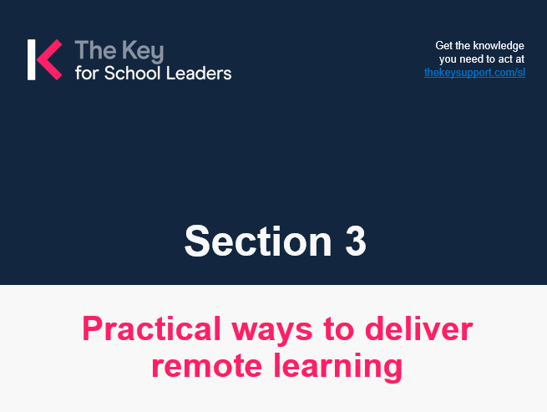
24 | 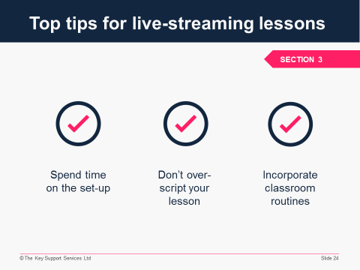 | Delete this slide if you’re not doing live streaming of lessons in your school.   Explain:  - You might be apprehensive about conducting a live lesson online, but remember – “personality, not perfection”  - Pupils aren’t going to worry if you make little mistakes or stumble over words – they’re looking for their teacher, not a newsreader  On the slide are 3 quick strategies to help you manage live-streaming lessons:  Spend time on the set-up – if pupils can see and hear you clearly, they’ll be more engaged – so remember to:  - Check the mic  - Check where the camera is  - Check the computer is at eye level, with your light source behind it  - Look directly at the camera when speaking  You should also check:  - The settings are how you want them  - The waiting room is enabled (if applicable)  - The video is set to grid view  - Your resources are ready to share  - Any sensitive/irrelevant tabs on your screen(s) are closed  Don’t over-script the lesson  - You don’t need to know absolutely everything you’re going to say beforehand  - Jot down a quick lesson plan in a few bullet points so you know what content you really need to deliver  - Be mindful of teacher input – this is even more relevant in the virtual classroom, where screen fatigue is real. Pupils might struggle to sit through one-way communication for a long time (as a guide, aim for 10-15 mins in total, depending on pupils’ age and your professional judgement). And, just as in classroom lessons, you’ll need to pause your delivery to give pupils enough thinking time to process new information and ideas  Consider classroom routines  - Make live-streamed lessons as close as possible to traditional classroom lessons – think back to those essential ingredients we talked about earlier and how they could be translated to remote delivery (adapt this if you adapted slide 15 and didn’t include classroom routines)  - If possible, make any adaptations you need together with your class(es) so pupils feel they have some  buy-in  - Try to use familiar language (an example of this for primary schools could be “carpet time”, but adapt this to include examples that suit your school)
25 | 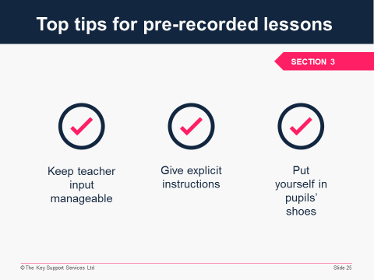 | Delete this slide if you’re not pre-recording lessons in your school.  - Explain:  On the slide are 3 simple considerations when preparing  pre-recorded lessons:  Teacher input  - As with live lessons, consider the amount of teacher input (the same guideline applies – around 10-15 minutes depending on pupils’ age and your professional judgement)  - Consider where it would be useful to encourage pupils to pause the lesson to think about any new information you’ve given  Give pupils explicit instructions  - It’s crucial that instructions are clearly articulated both in pre-recorded content and any written instructions  - (Our expert suggested the Edpuzzle app, which allows you to build in breaks to videos, so they can only be unpaused once the pupil has completed an action – you may wish to mention this here if you’re happy for your staff to use it)  Think about the pupil  - You’ll need to construct your lesson so that the content, input and resources are easy to access both by pupils and possibly parents/carers  - Put yourself in the pupils’ shoes and look at your lesson – is it clear? Easy to navigate? Is it easy to find a link or a folder if needed? (Our expert suggested ThingLink, which allows you to add additional information and links to videos – you may wish to mention this here if you’re happy for your staff to  use it)
26 | 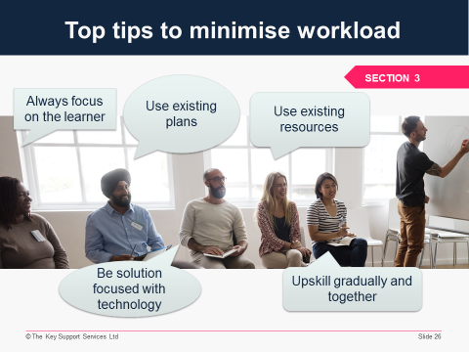 | - Explain:  We want to minimise, as much as possible, the impact of remote learning on your workload. These are a few tips to bear in mind to try to help with this.  Always focus on the learner  - We know you do this anyway! In the context of remote learning it just means that, instead of focusing on the delivery, start with the learning outcomes you want to achieve and work back from there – pedagogy remains the focus, and any tech you use should be in the service of the learning experience  - Not every lesson will require live or pre-recorded input  Use existing plans  - You don’t need to re-invent the wheel!  - Work with current plans and see how you can adapt them for remote teaching  Use existing resources  - There are a plethora of resources at your disposal – use them!  - (Add examples according to what your staff have available to them and in line with your remote learning approach – for example, you might be happy for them to use resources from Oak National Academy, BBC Bitesize, certain YouTube channels, or from companies your school already uses)  Be solution-focused with technology  - Having access to endless apps and tools can be overwhelming, so take a solution-focused approach when choosing tech – think: what’s the particular problem I need to solve?  - (Add examples, in line with the online learning platform/tools your school is using, of how particular functions/tools might solve particular problems – for example, if the problem is difficulty in getting pupils to collaborate, or giving feedback effectively)  - For support with this, speak to (insert relevant staff member)  Upskill gradually and together  - We’re not expecting you to become experts overnight – take your time with this  - Focus first on getting the basics right, and practice them frequently before exploring new tools to use with your pupils

Wrapping up: what’s next?
3 minutes (without questions)
Resources required: n/a
27 | 
28 | 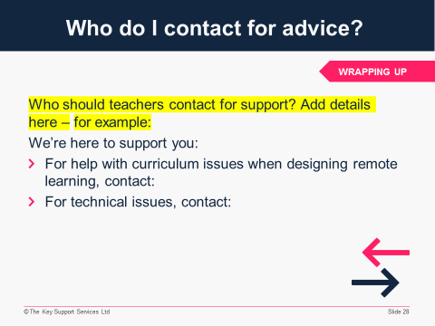 | Edit this slide in advance.  - Explain:  - This is where to go if you have any difficulties with planning or delivering remote learning  - Please make a note of this
29 | 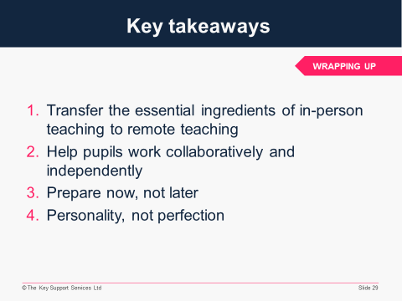 | Edit this slide in advance – you may wish to add your own key takeaways here.  - Explain:  On the slide are 4 key things to take away from this session:  1. Transfer the essential ingredients of in-person teaching to remote teaching  - Maintain relationships between you and your pupils  - Replicate classroom routines where possible  - Use our remote teaching set-up to provide feedback and do formative assessment  - Remember, the ‘what’ is more important than  the ‘how’  2. Help pupils work collaboratively and independently  - Build in opportunities for them to work together, as this can provide motivation and improve learning outcomes. Again, try to transfer what you already do  - At the same time, make sure they’re equipped to work independently. Think about things like time management skills, chunking work and staggering tasks, scaffolding and confidence building, enabling reviewing of their work, and self-selecting tasks  3. Prepare now, not later  - Use the time you have now to get ready  - Talk to pupils now about remote learning and what’ll be expected of them if they need to learn at home  - Agree classroom rules and practices (they may be different from usual)  - Discuss any challenges and find solutions together  - Get to grips with the basics of your tech now too.  You don’t need to become tech experts – knowing the basics to do what you need to do is enough  4. Personality, not perfection  - Don’t worry too much about having the perfect live lesson or video input  - Maintaining relationships with pupils and giving them strong pedagogical content is more important than perfect delivery  - To close, acknowledge this is an area we’re all still getting to grips with, and it’ll take time and effort to make it work well, but please be reassured about our expectations – this is about adaptation rather than reinvention. Remember – teaching remotely is still teaching, and this is what you do best!  If you have time and feel comfortable doing so, ask staff if they have any questions about what you’ve discussed.  If you’d rather address questions individually, tell staff how to contact you with questions.
30 | 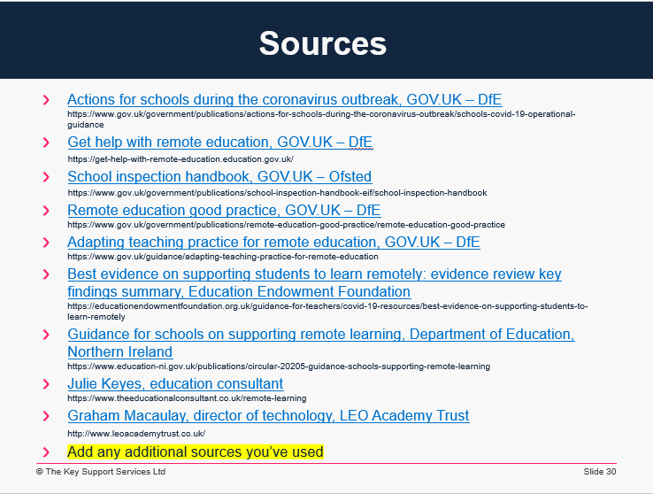 | - This slide lists the resources used to write this briefing. Add any additional sources you’ve used when adapting it  - The information in this briefing, prior to any adaptations you may make, is correct as at 19 October 2021  - Please note: any references to commercial products or services throughout this briefing are not intended as an endorsement by The Key

